Form, 2nd

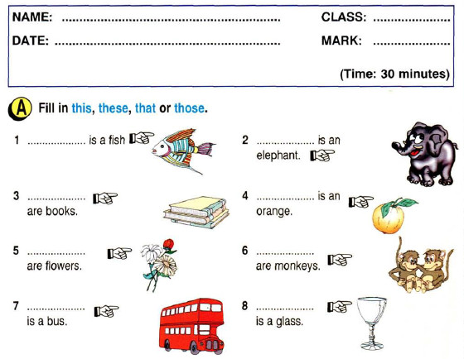

II. Выбери правильный вариант.

Example: Do you want to ____in this nice lake?

1. play
2. swim
3. run

1. My white________ has got six chickens.

1. 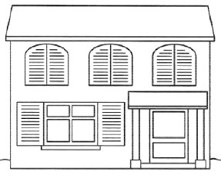duck
2. hen
3. monkey
4. I’m sorry, I don’t____________English songs.
5. see
6. help
7. know
8. My brother is not__________. He is a good pupil.
9. clever
10. good
11. lazy
12. I’m OK. I am not .
13. happy
14. tired
15. fine
16. I’m sorry, I am not to go to the park.

a) hungry

b) ill

c) ready

1. Ann is not well today. She is in bed. She is …
2. ill
3. kind
4. hungry

**III. С чего начинается каждый вопрос?**



they want to go to the Zoo?

they at the Zoo?

they go to school?

you got guitar?



they work in the hospital?

you got a bear?

you a hockey fan?

you play basketball?

they got zebras in the zoo?

**IV . Образуйте множественное число существительных**

A woman _________

A kitten ___________

A horse ___________

A man ____________

An aunt ___________

A wife ____________

A friend ___________

A child ____________

